**Coding Assessment – SQL**

**By Afreen Sultana A**

create database OyoBusiness;

use OyoBusiness;

create table OYO_city (

hotel_id INT PRIMARY KEY,

city VARCHAR(50)

);

create table OYO_sales (

booking_id INT PRIMARY KEY,

customer_id INT,

status VARCHAR(20),

checkin DATE,

checkout DATE,

number_of_rooms INT,

hotel_id INT,

amount DECIMAL(10, 2),

discount DECIMAL(10, 2),

date_of_booking DATE,

FOREIGN KEY (hotel_id) references OYO_city(hotel_id)

);

insert into OYO_city values (56, 'Bangalore');

insert into OYO_city values (45, 'Delhi');

insert into OYO_city values (16, 'Gurgaon');

insert into OYO_city values (14, 'Kolkata');

insert into OYO_city values (15, 'Pune');

insert into OYO_city values (10, 'Mumbai');

insert into OYO_city values (7, 'Chennai');

insert into OYO_city values (18, 'Hyderabad');

insert into OYO_sales values

(1, 201, 'stayed', '2025-07-19', '2025-07-20', 1, 56, 2000, 100, '2025-07-19'),

(2, 202, 'stayed', '2025-07-22', '2025-07-23', 1, 45, 2500, 200, '2025-07-20'),

(3, 203, 'stayed', '2025-02-21', '2025-02-22', 1, 16, 2300, 150, '2025-02-19'),

(4, 204, 'stayed', '2025-03-01', '2025-03-02', 1, 14, 1800, 100, '2025-02-28'),

(5, 205, 'stayed', '2025-08-01', '2025-08-03', 2, 15, 3000, 300, '2025-06-25'),

(6, 206, 'Cancelled', '2025-01-11', '2025-01-12', 1, 10, 2800, 150, '2025-01-01'),

(7, 207, 'No Show', '2025-07-20', '2025-07-21', 1, 16, 2200, 100, '2025-07-20'),

(8, 208, 'Cancelled', '2025-07-22', '2025-07-23', 1, 7, 2100, 100, '2025-07-21');

**----Coding Assessment (21-7-25)----**

**----1. Average Revenue after discount per city------**

select c.city,AVG(s.amount - s.discount) as avg_revenue from OYO_sales s INNER JOIN OYO_city c ON s.hotel_id=c.hotel_id where s.status='Stayed' group by c.city order by avg_revenue DESC;

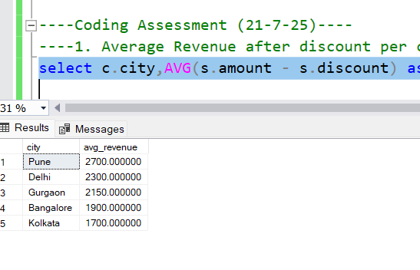

**----2. Minimum Number of Rooms booked per city------**

select c.city, MIN(s.number_of_rooms) as min_rooms from OYO_sales s INNER JOIN OYO_city c ON s.hotel_id=c.hotel_id where s.status='Stayed' group by c.city order by min_rooms ASC;

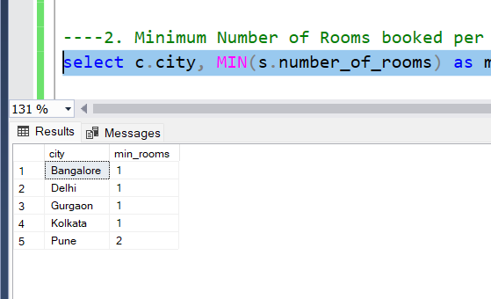

**----3. Avg, min and max room amount per city-----**

select c.city, AVG(s.amount) as avg_amount, MIN(s.amount) as min_amount, MAX(s.amount) as max_amount from OYO_city c LEFT JOIN OYO_sales s ON c.hotel_id=s.hotel_id AND s.status ='Stayed' group by c.city order by avg_amount DESC;

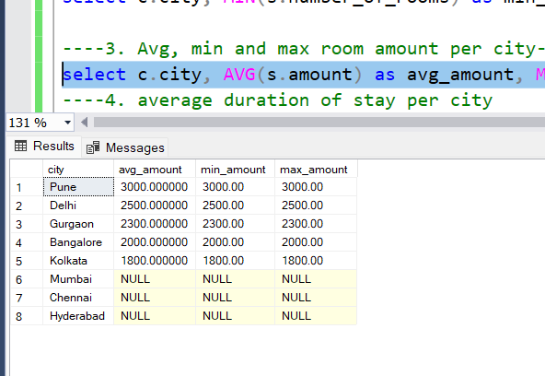

**----4. average duration of stay per city**

select c.city, AVG(DATEDIFF(DAY, s.checkin, s.checkout)) AS avg_stay_duration from OYO_sales s RIGHT JOIN OYO_city c ON s.hotel_id=c.hotel_id AND s.status='Stayed' group by c.city order by avg_stay_duration DESC;

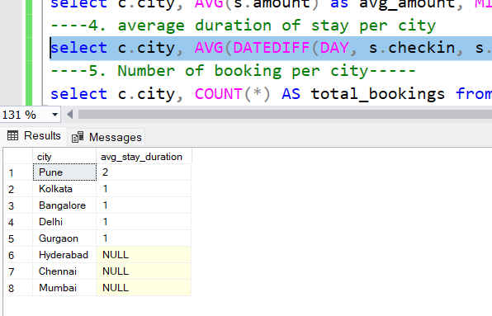

**----5. Number of booking per city-----**

select c.city, COUNT(*) AS total_bookings from OYO_sales s INNER JOIN OYO_city c ON s.hotel_id=c.hotel_id where s.status='Stayed' group by c.city Order by total_bookings DESC;

